# **CHAPTER 5 SYSTEM DESIGN**

## **5.1 Architectural Design**

### **5.1.1 Flowchart**

A flowchart is a diagrammatic representation of sequence of logical steps of a program. Flowcharts use simple shapes to describe the processes that occur. Arrows are used to show the relationship between entities and how data flows.

### **5.1.2 Context Diagram**

The [Context Diagram](https://www.modernanalyst.com/Resources/Articles/tabid/115/ID/1355/Introduction-to-Context-Diagrams.aspx) shows the system under consideration as a single high-level process and then shows the relationship that the system has with other external entities.

### **5.1.3 Data Flow Diagram level 1**

A data flow diagram (DFD) maps out the flow of information for any process or system. It uses defined symbols like rectangles, circles and arrows, plus short text labels, to show data inputs, outputs, storage points and the routes between each destination.

**5.2Database Design**

### **5.2.1 Database table names and description**

|  |  |
| --- | --- |
| **Table name** | **Table Description** |
| Users | It stores details about the users of the system. This includes both car owners and mechanics. |
| Cars | It keeps record of all cars that have been registered. |
| Repairs | It stores all repair activities performed on vehicles. |
| Ratings | It stores the rating scores given to each mechanic by car owners. |
| Map details | It is used to store the location coordinates of mechanics. |

### **5.2.2. Entity Relationship Diagram**

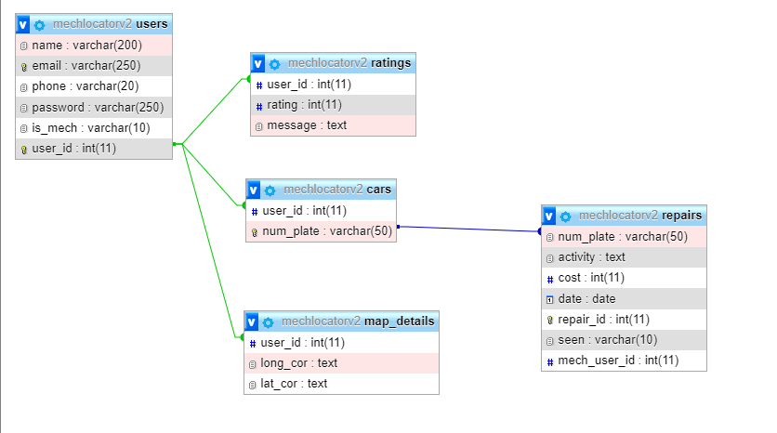

## **5.3 User Interface Design**

### **5.3.1 Sign up page**

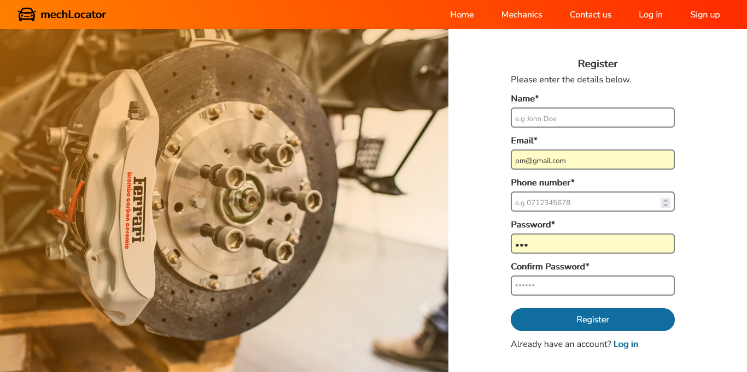

### 5.3.2 Login page

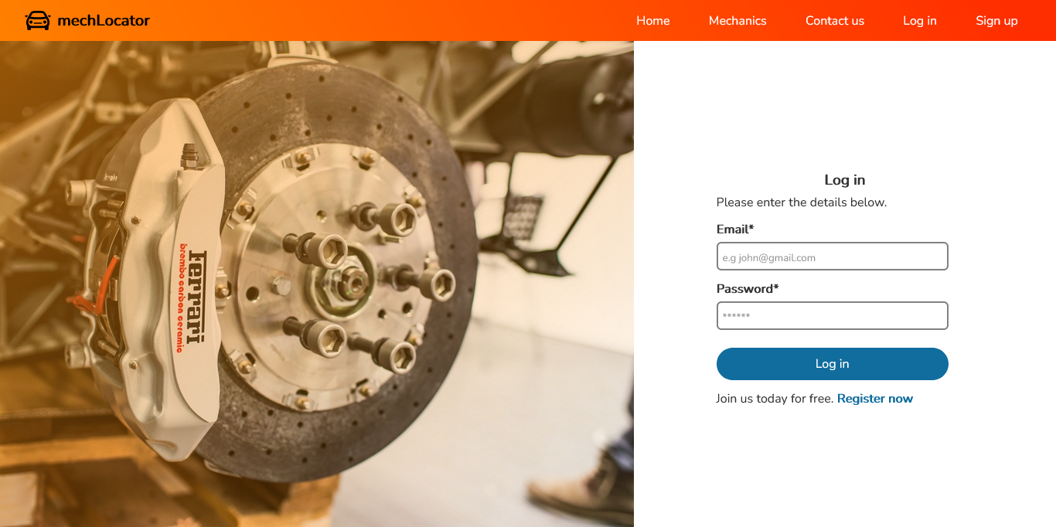

### 5.3.3 Homepage



Figure 1Homepage

### 5.3.4 Registering a car modal

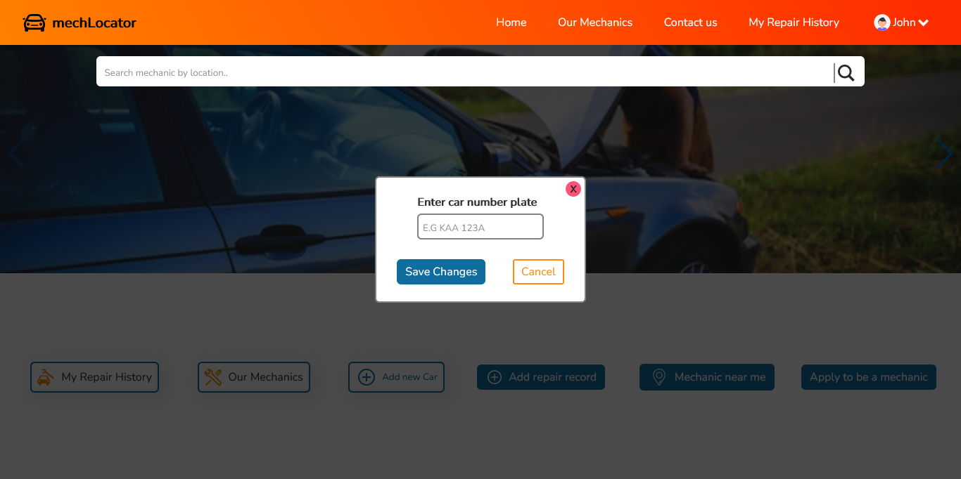

Figure 2Registering a car modal

### 5.3.5 Adding a repair record page

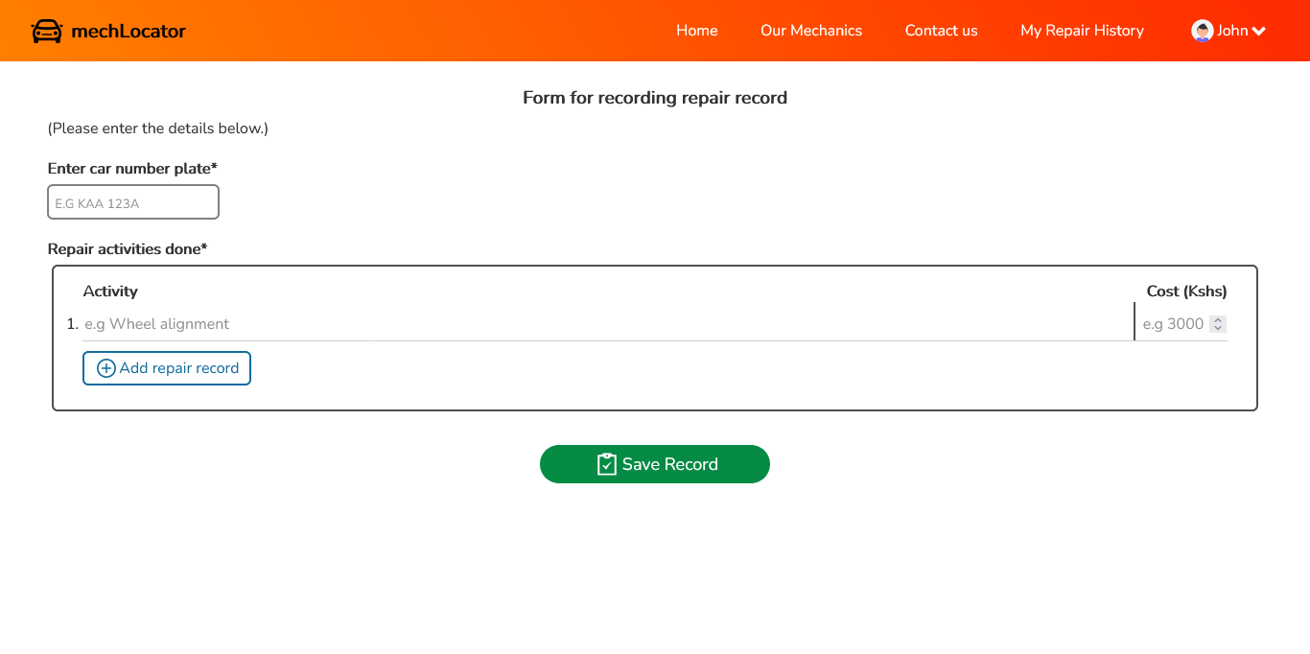

Figure 3Adding a repair record page

### 5.3.6 Car repair history page

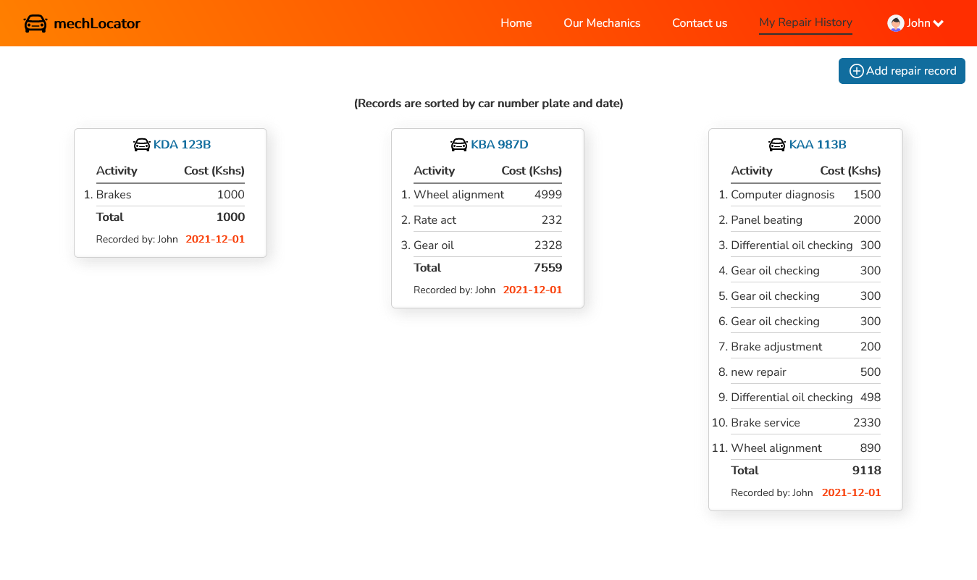

Figure 4Car repair history page

### 5.3.7 All mechanics on the platform

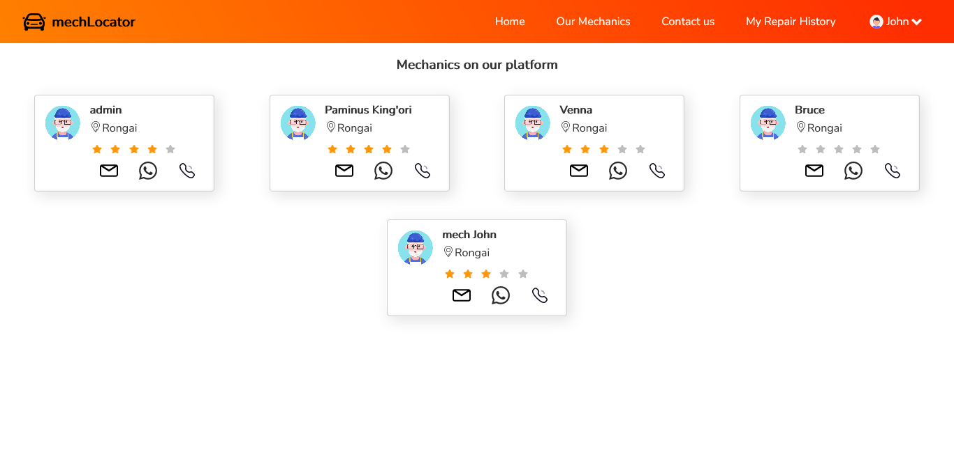

Figure 5All mechanics registered

### 5.3.8 User profile page

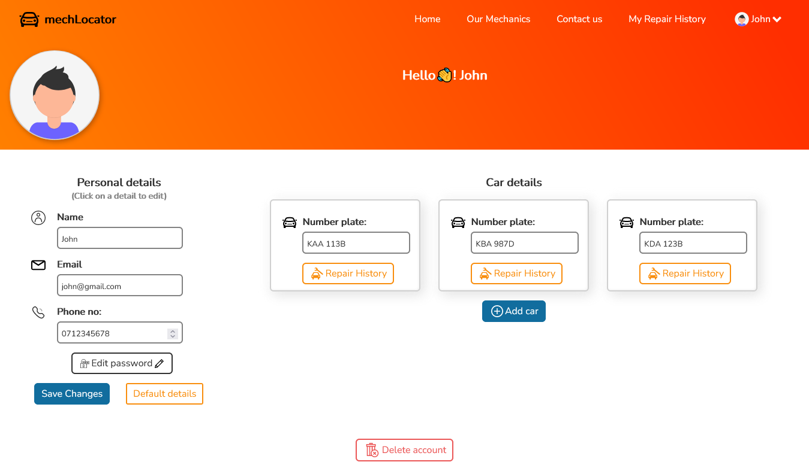

Figure 6User profile page

### 5.3.9New notification page

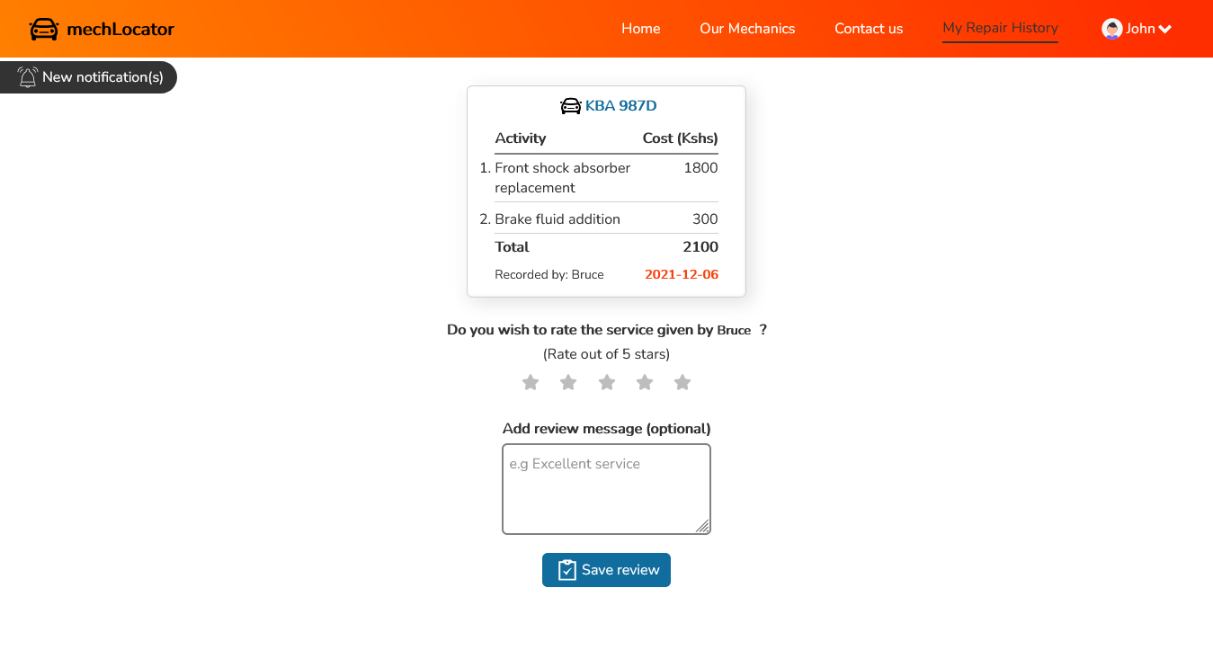

Figure 7New notification page

### 5.3.10 Contact page

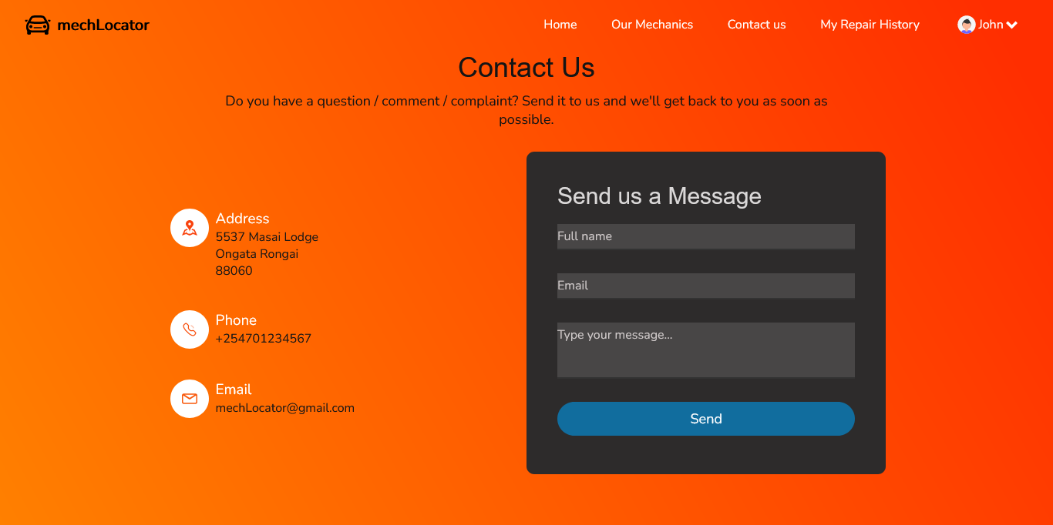

Figure 8contact page